The steps to perform the copy activities in Azure Datafactory (ADF) are as follows:

**Step-1**: We need to create a 2 separate storage account (one for source where we need to keep a file or application in it and another one is for destination where we need to move the file or application from the source storage to the destination storage). We can use **Azure Blob Storage** or **Azure Datalake Gen 2**. But for now, we will use Azure Blob Storage for both storage accounts. The below image shows us the 2 Azure Blob Storage account.

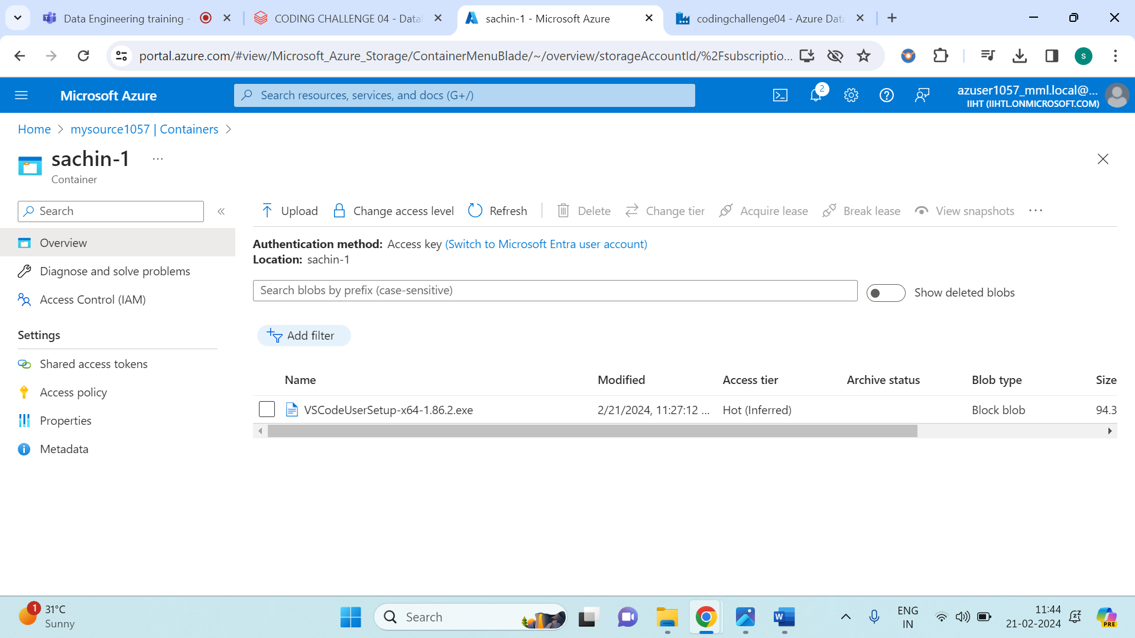

The above image shows us that i have created an initial account named **mysource1057** storage account and i have created a container named **sachin-1** and inserted two applications.

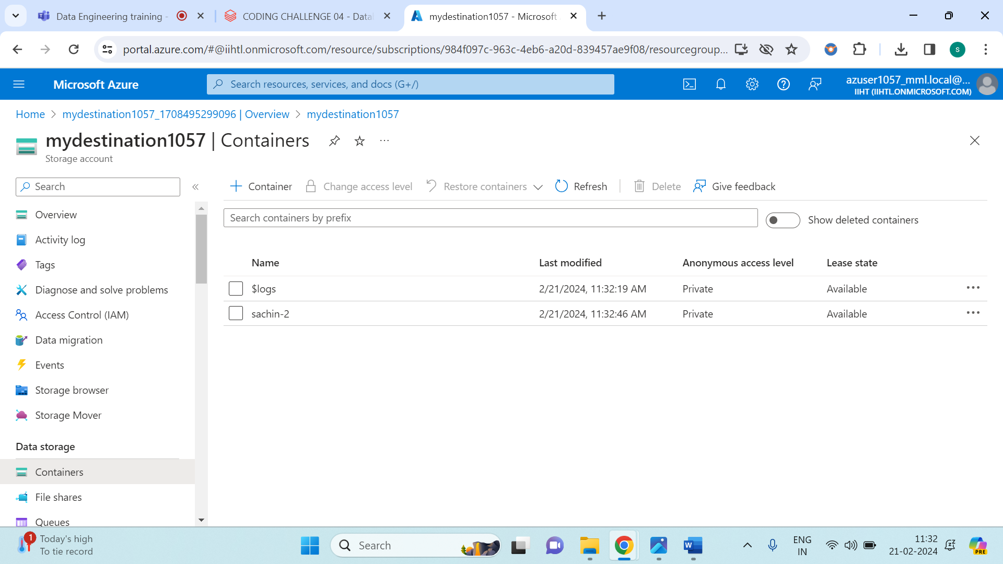

The above image shows us, that I have created another storage account named **mydestination1057** account and I have created a container named **sachin-2** and it is empty (since, we needed to copy the data from the source to the destination).

Once we have created 2 storage account, the later steps is to create a Azure Datafactory. Once we have created the azure datafactory we need to click ‘Go to resource’ and the we need to click ‘Launch studio’. After following these you need to get this interface as shown below.

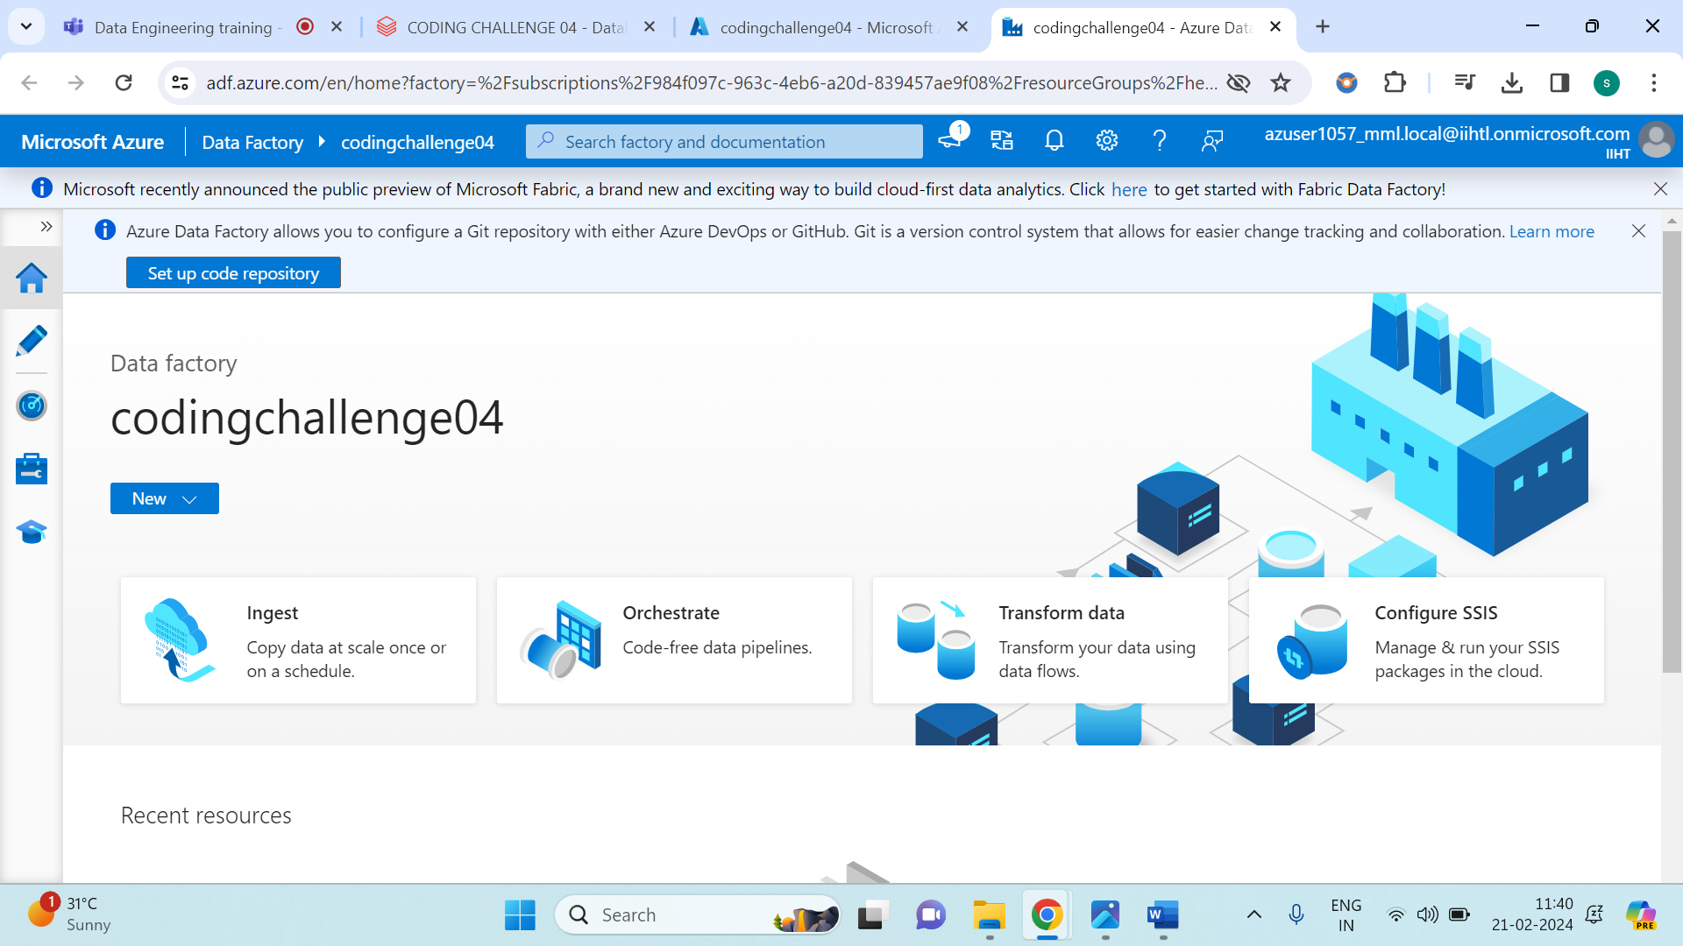

From the above image, select ‘Ingest’.

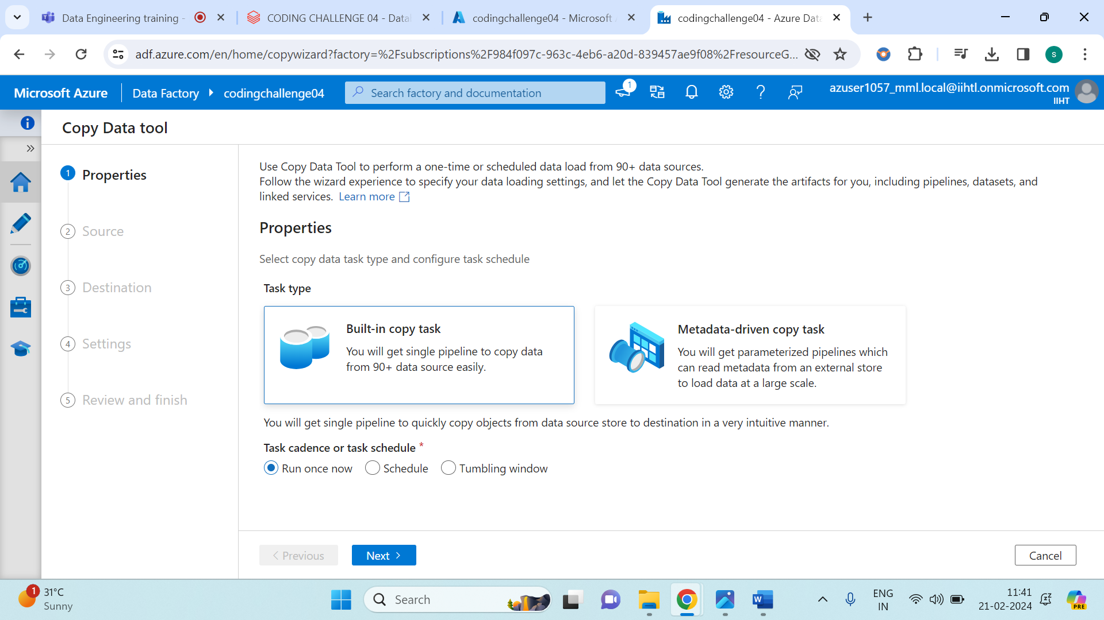

Click on next

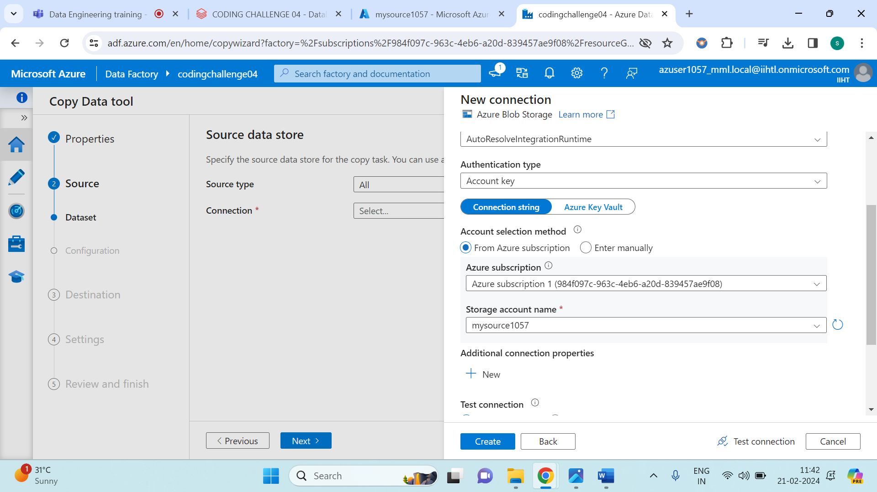

Mention your storage name and keep everything as same and click on next.

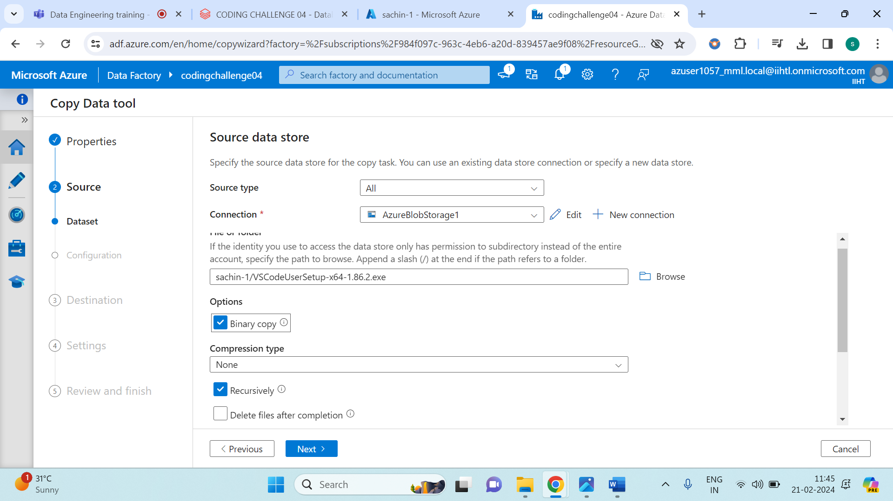

From the above image we need to browse the file select the application which you wanted to transfer and tick mark on ‘Binary copy’ and click on next.

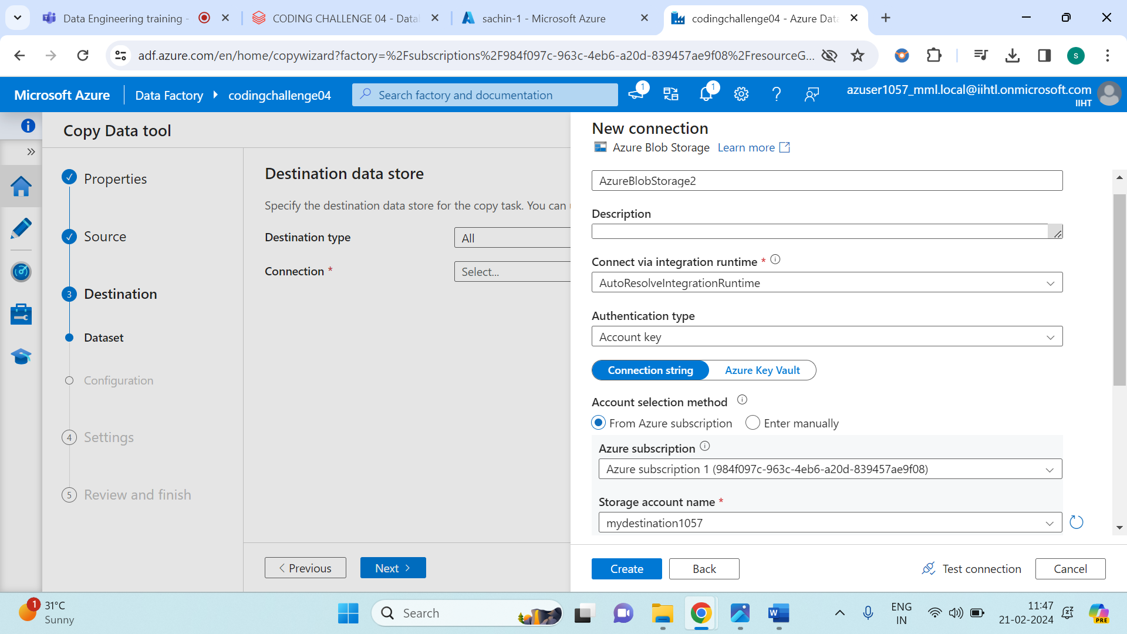

Give your storage account name in the destination data store and leave the rest and click on next.

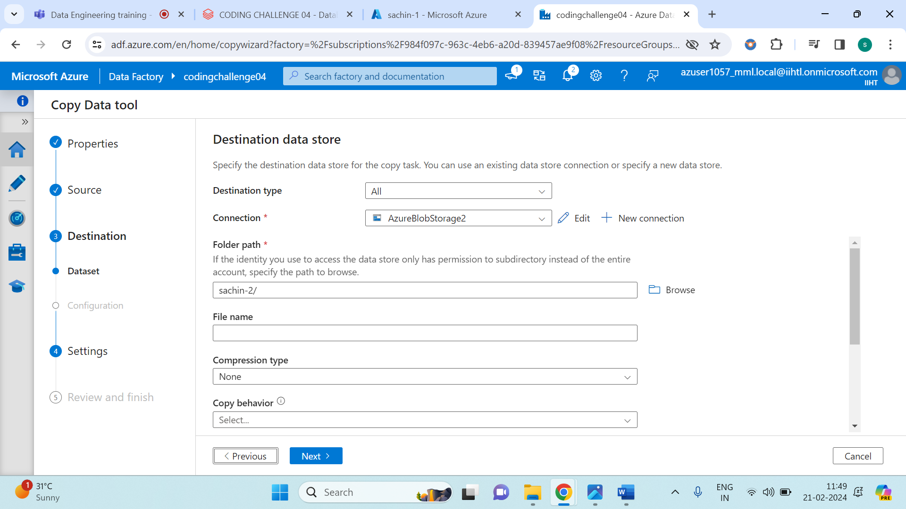

Browse your location of destination storage account.

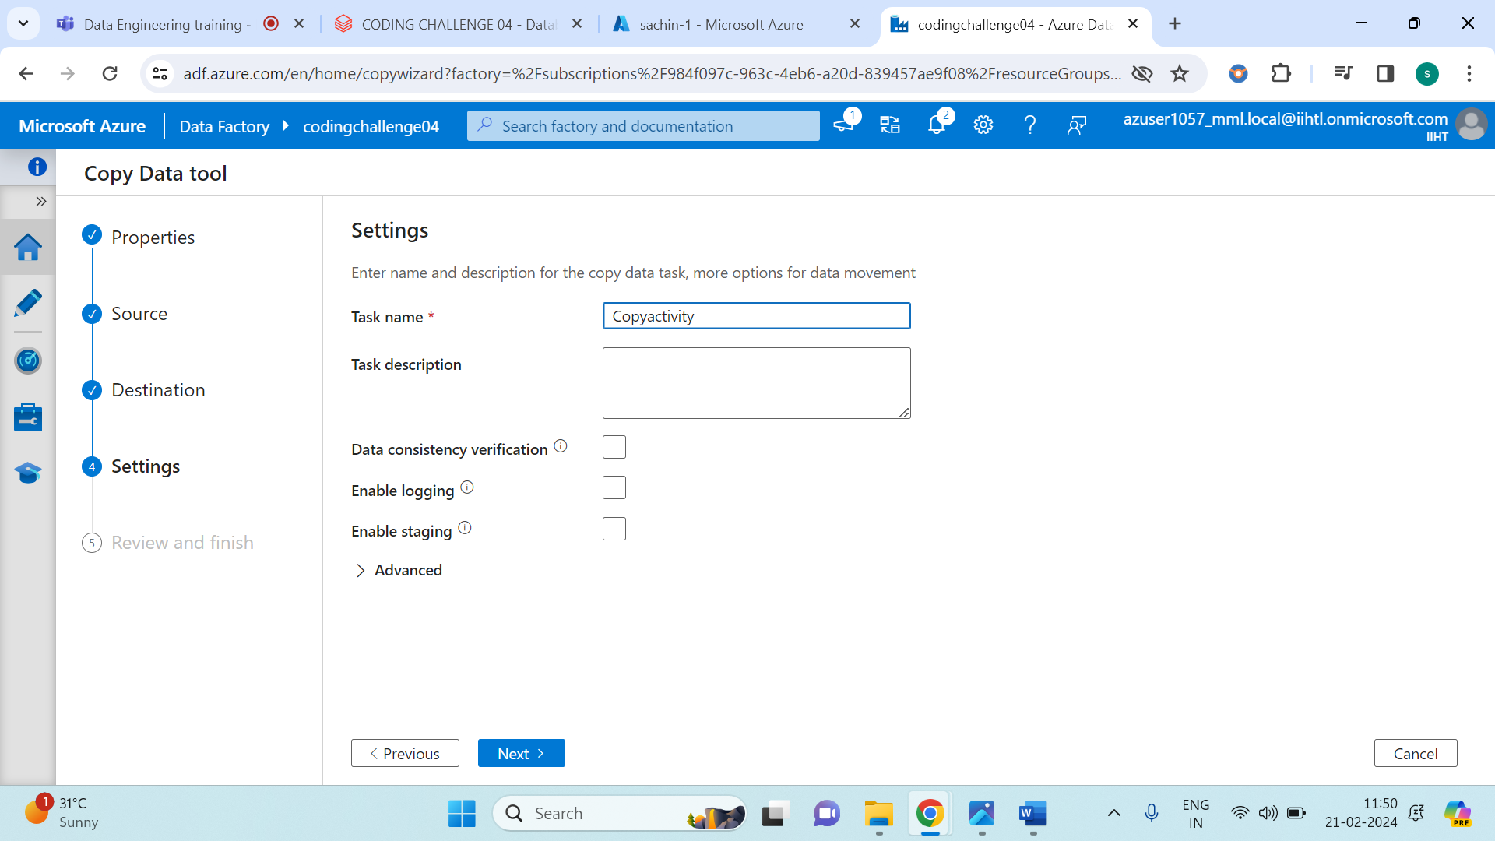

Mention a task name as shown in above image.

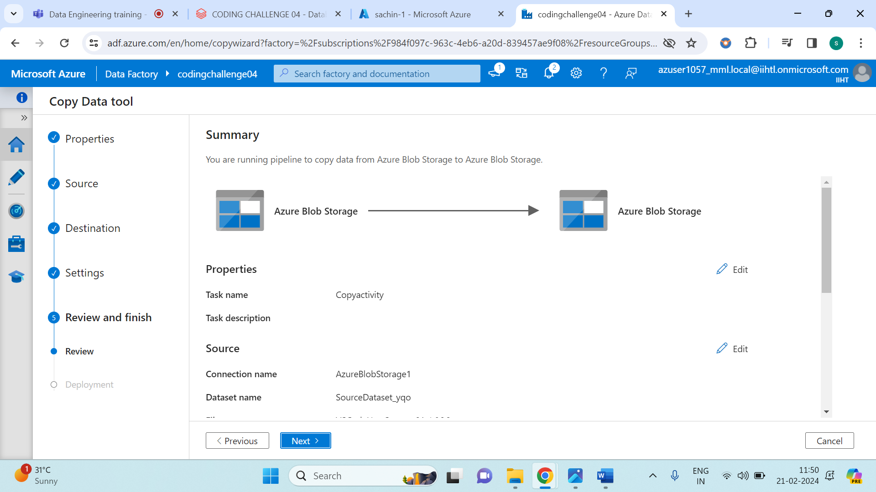

Check once if all are right and click on next.

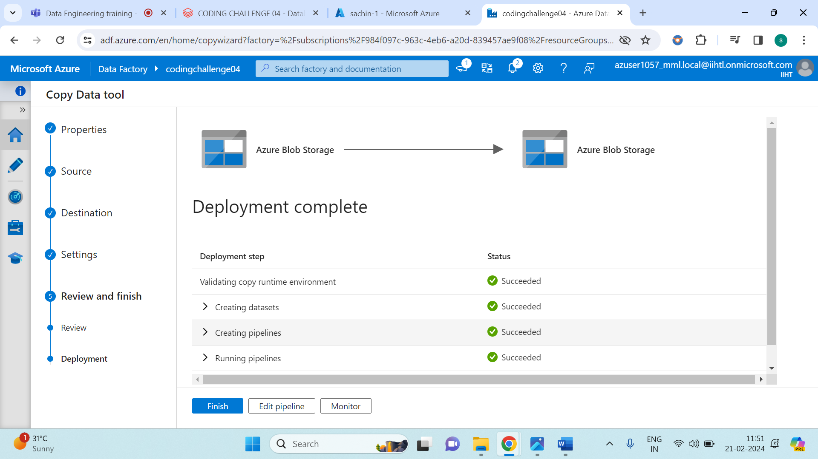

Click on monitor and the all set. Your task is done.

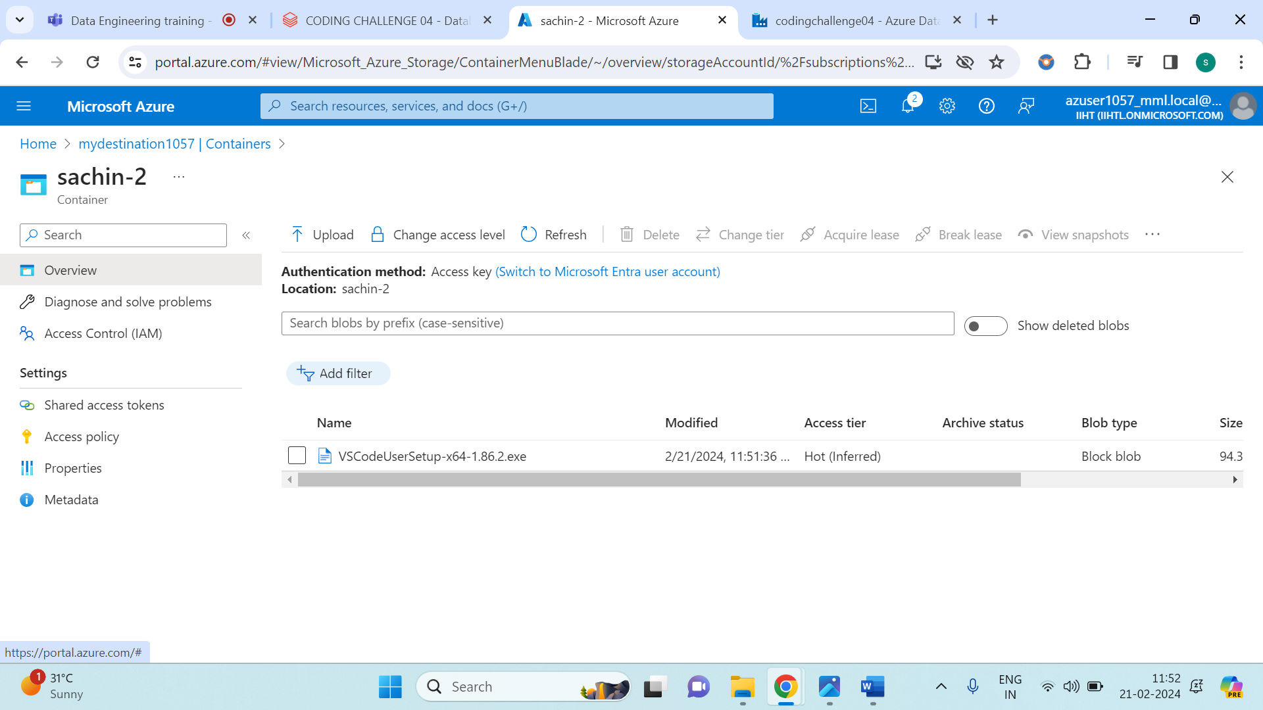

The above image shows us the application which was in **mysource1057** is successfully transferred to **mydestination1057**.

Overall, this shows us the **Copy Activity in Azure Datafactory (ADF)**.